

**CAT**

ACADEMIC YEAR**: 2024 - 2025**

LEVEL or CLASS: **YEAR TWO**

TERM: **THIRD TERM**

COURSE title: **3D Models**

COURSE CODE:

NUMBER OF TEACHING HOURS/WEEK**: 2**

DATE: **14/05/2024**

DURATION: **180 Min**

MAXIMUM MARKS: **20**

**INSTRUCTIONS:**

1. Attempt **ALL** questions
2. For question **5 model only one image** from image **1** to image **5**
3. Write your **FULL NAMES** and your **CLASS**
4. Name your model in this format sample **Y2A_YOUR_NAME_IMAGE_1.blend**
5. Submit your model on **/home/yearTwo/termThree** directory

**Examiner:** RWAGAJU Aphrodice

Given the images (1 to 5) of robot model captured from different angles and its parts. Choose one that seems easy for you to model and model it using blender software or any other software of your choice. (See the images from page 3 to page 4) **(10 marks)**

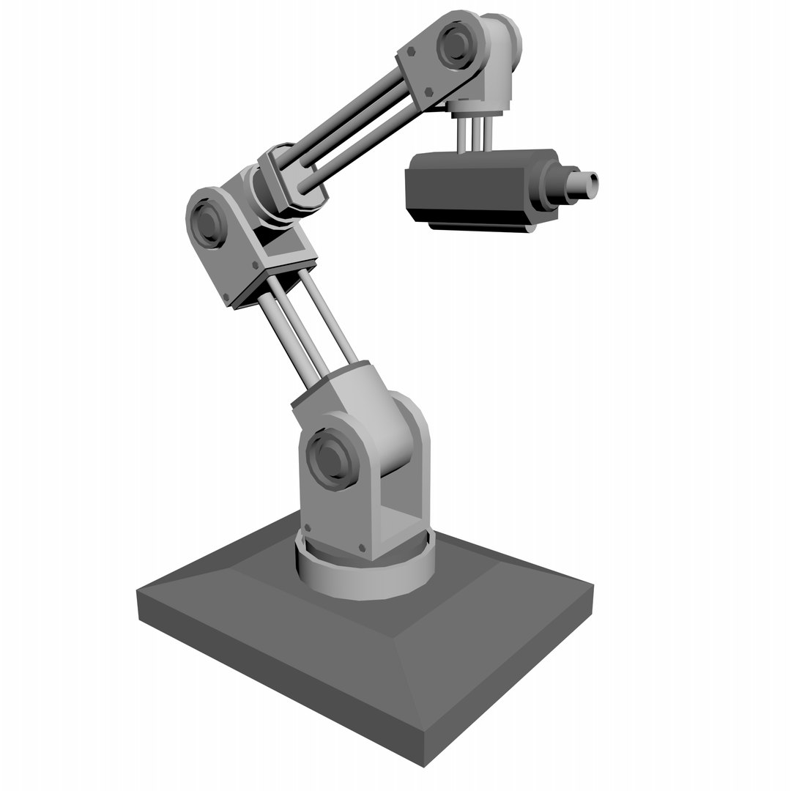Image 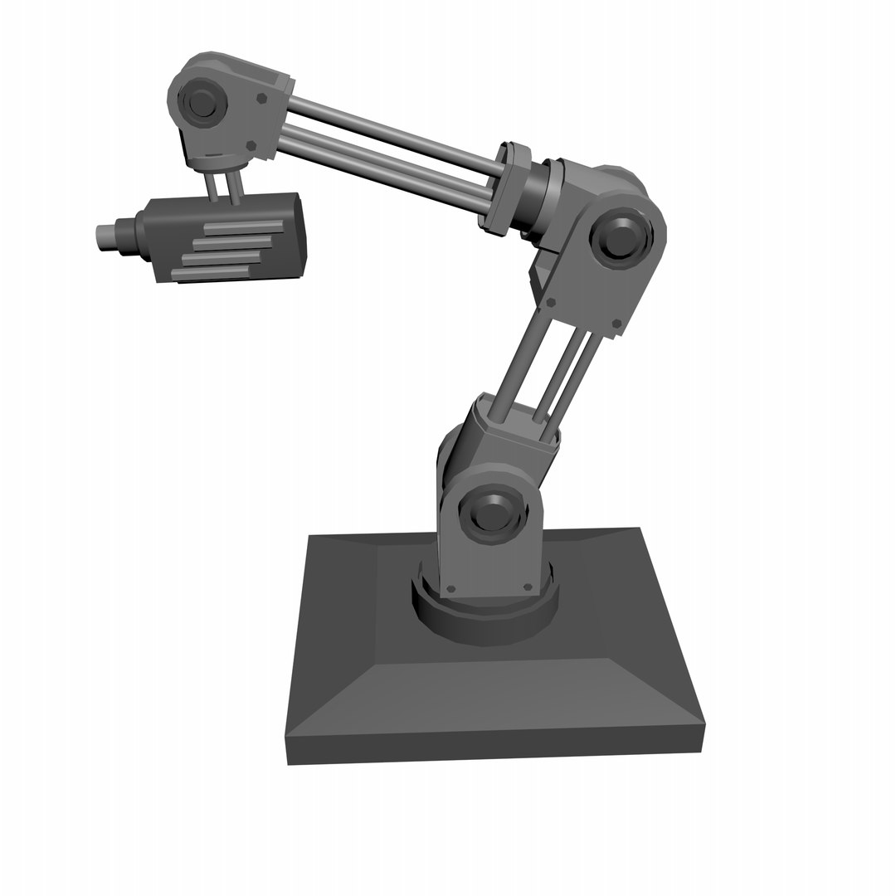1

Image 2

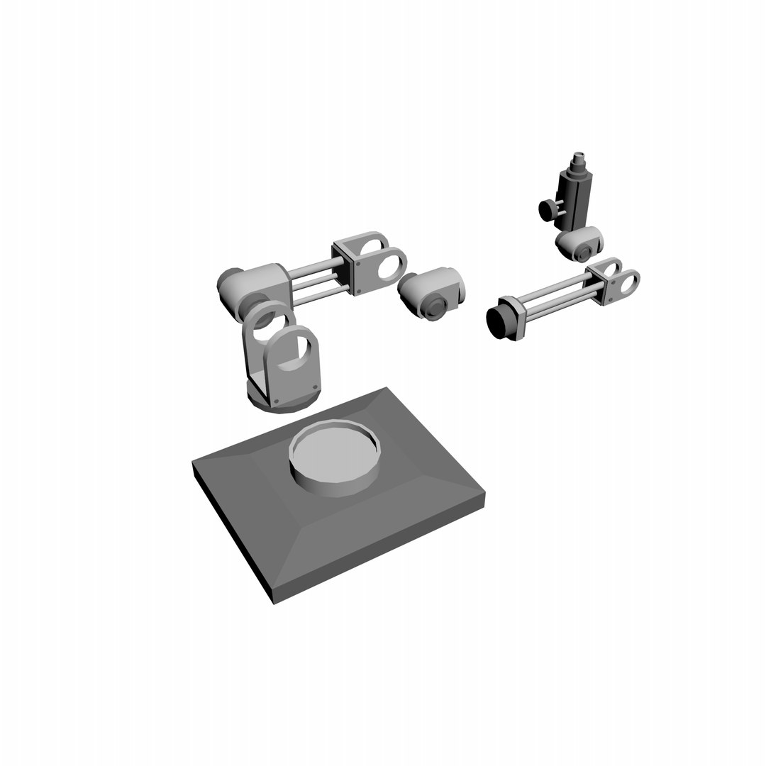

Image 3: Robots parts (Model all of them once this image is attempted for modelling)

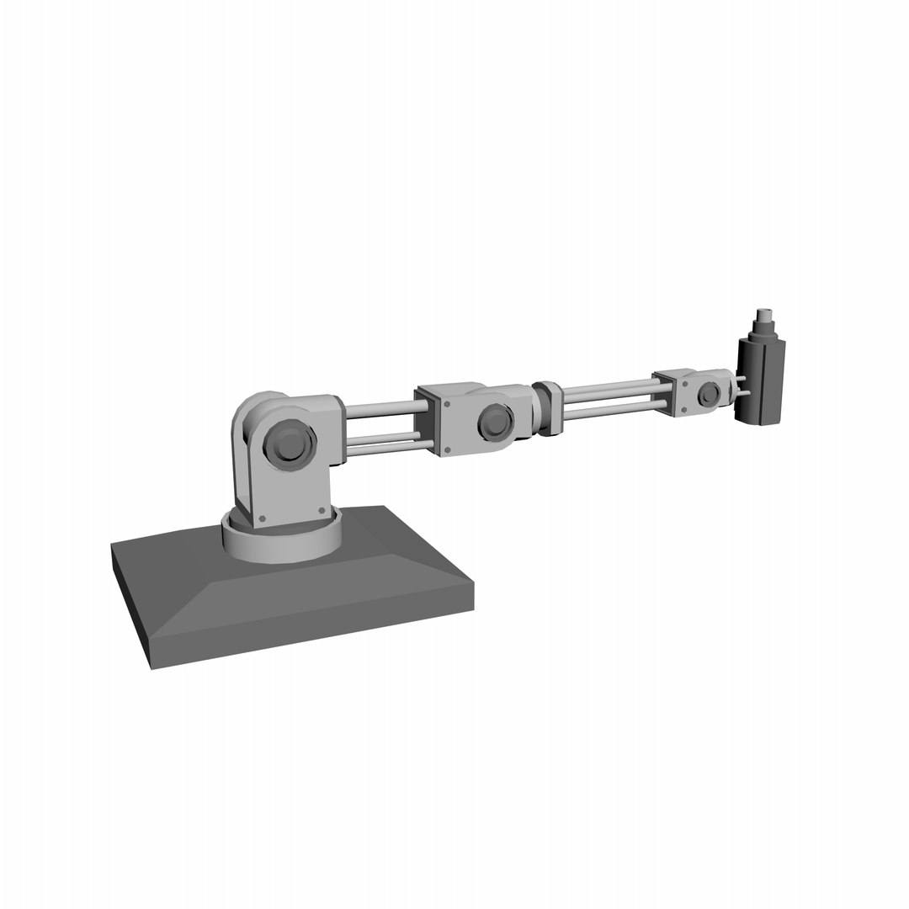

Image 5

**GOOD LUCK!**